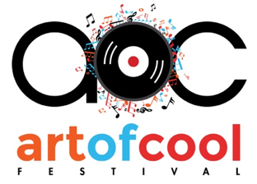

The Art of Cool Festival 2019 Media Application
AOCFEST 2019 is open to approved working media, photographers, and web and digital content producers. The credential application must be completed for each staffer who plans to attend.

Name:

Email:

Phone Number(s):

Address:

Website/Blog/Outlet (if freelance, list outlet(s)):

Circulation or Audience Size?

Are you on assignment? Yes/No

If so, are you able to provide verification of your assignment? Yes/No

Have you attended AOCFEST as media in the past? Yes/No

Which days will you be attending, or will you attend all weekend?

Please attach samples or links to Original Content, Other Festival Coverage.

Other notes or considerations:

Thank you!

